First In First Out (FIFO), with a little priority mixed in.

Use the ladders to help speed up the ones that are already docked, (both ladders on one), as there’s only one pump anyway so focusing on one would be better.

There’s only going to be one queue for passengers as they will be focused on the current task.

Bigger jets will have a higher priority, so there will be priority values, also dependant on current fuel.

Waiting in air issue shouldn’t be as bad as the ground is focused on getting planes out quicker, so it won’t be slow on two planes as they all rely on one pump anyway.

Emergencies will take priority over everything.

There is a potential to speed this up even more, should you be able to pump and load at the same time.

Okay so the plan is: FIFO with Priority.

Emergencies > Highest Capacity of Passengers > FIFO

Ladders should be focused on the plane at the pump. Focus on getting any plane away from the pump, until all planes are off then give the ladder to the waiting plane.

These bigger companies will have higher priority in our queue, meaning they will bump in place (safely) to help get more people through. The bigger planes still have a higher weighting in passenger volume in than the 7-10 smaller flights, so reducing time will need to focus on these larger planes.

Waiting in air issue will revolve around the ‘emergency’ part of our order, such that low fuel take priority, and since the 7-10 before big plane should prevent planes being in the air too long if they are low capacity. Longer they are in the air, higher the priority.

Emergencies are important above all. Whichever plane can be cleared faster (moved onto Shortest Time Remaining scheduling) to help get a plane out to allow a[/;n emergency.

Shortest Job First would really disadvantage larger jets

Shortest Time Remaining ^^^^^^^^^^^^^^^^^^^^^^^^^^^

Non-preemptive is basically priority, and focuses on the given task until finished then given another.

Round-Robin wouldn’t work, as where would you store the planes you didn’t finish on, would

be pretty good if you had perfect scheduling and no issues arrived.

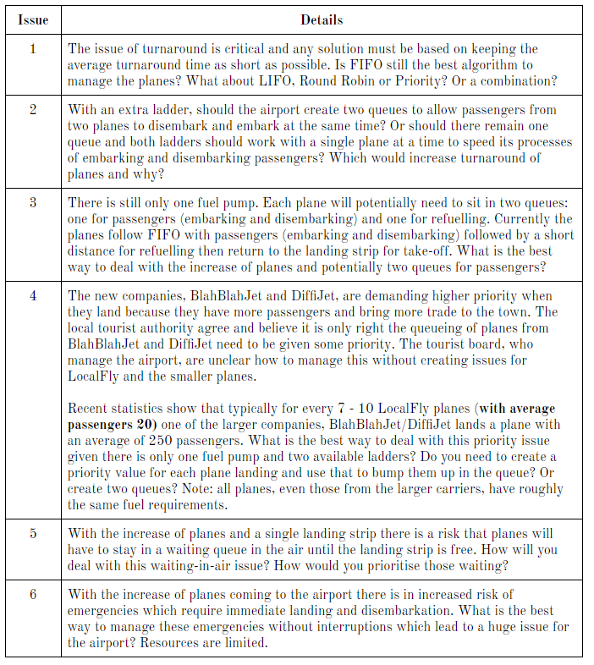

Issue 1

First In First Out (FIFO), with a little priority mixed in where when the big planes come we will give them priority as the big planes have 234 and 275 passengers and the smaller planes have a max of 24, so giving the big planes priority will lower the average wait time per passenger a significant amount, whereas the smaller ones would increase it.



Issue 2

We will use FIFO in terms of it will start with whoever is in the fuel station and moving back to the previous planes from there.



Issue 3

Look above lmao



Issue 4

As both planes have the same fuel requirements the larger companies will be given priority because of the face that there are 250 passengers it would be beneficial to get that plane of the ground first rather then a place with 10% of the number of passengers



Issue 5

Waiting in air issue will revolve around the ‘emergency’ part of our order, such that low fuel take priority, and since the 7-10 before big plane should prevent planes being in the air too long if they are low capacity. Longer they are in the air, higher the priority.

Emergencies are important above all. Whichever plane can be cleared faster (moved onto Shortest Time Remaining scheduling) to help get a plane out to allow an emergency.



The reason why we pick FIFO mixed in with a priority system is to determine which planes should go at a certain point, emergencies are the highest priority, this means that above all else these planes will go first, while this may cause interruptions it allows for the least chances of anything going wrong, and as Resources are limited you wanna save as much as possible so better save than sorry.